## Screen List

|  |  |
| --- | --- |
| **Partner** | **Admin** |
| Login | Login |
|  | Partner Management   * Add new Partner |
| Locations List   * Add new location | Locations List |
| Offers List   * Add new offer | Offers List |
| Rate List   * Add rates | Partner Charge Configuration |
| Settings | Global Configuration |
|  | Users List |

## Login

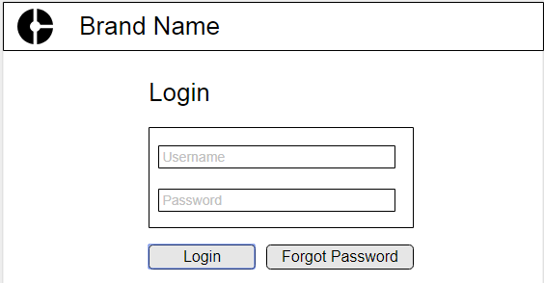

Validations – Username & Password are mandatory fields, Length – 50 characters each

## Partner Management (Admin Login)

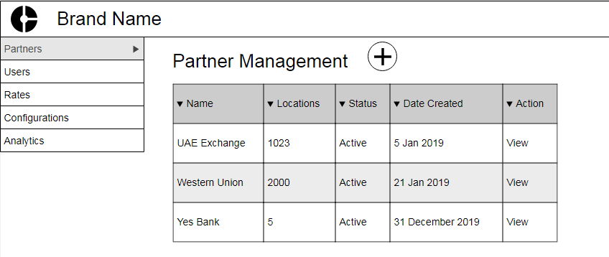

### Actions

1. When user clicks on View link – Navigate to Partner Details - Location
2. When user clicks on Add icon – it should show Add partner modal popup dialog.

## Partner Management - Add Partner (Admin Login)

### 

## Partner Details – Locations (Partner Login)

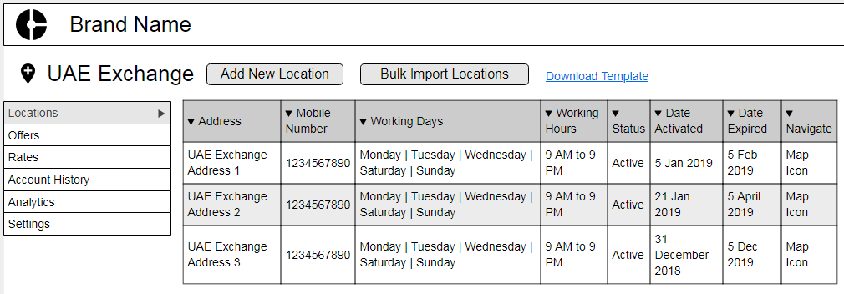

### Actions

1. When user clicks on Add new location– Navigate to Add New Location.
2. When user clicks on Bulk import locations – it should show allow user to upload the excel file.
3. When user clicks on Download template, download this excel file.

### Note

**Admin login** can have same view (but Add New Location, Bulk Import, Download link will be hidden).

## Add Locations

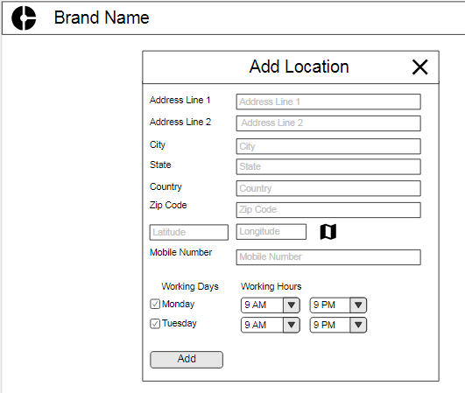

**Note:** Get GEO codes from Google GEO Code API before calling Save API to add new location.

## Partner Details – Offers (Partner Login)

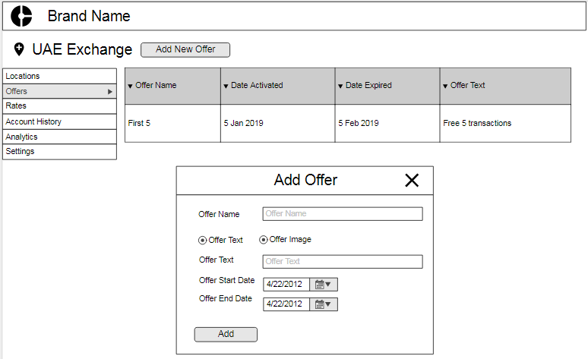

## Custom Partner Charges

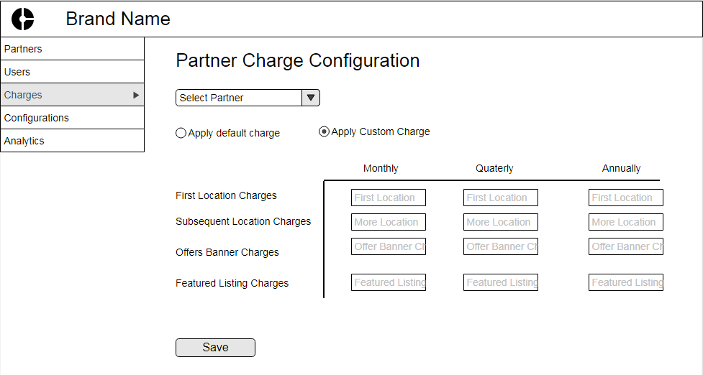

**Note:** When Apply Default charge is selected, UI should get default charges using /api/ getDefaultCharges. When partner charges are being saved through Save API – UI need to pass the default rates.

## Global Configurations

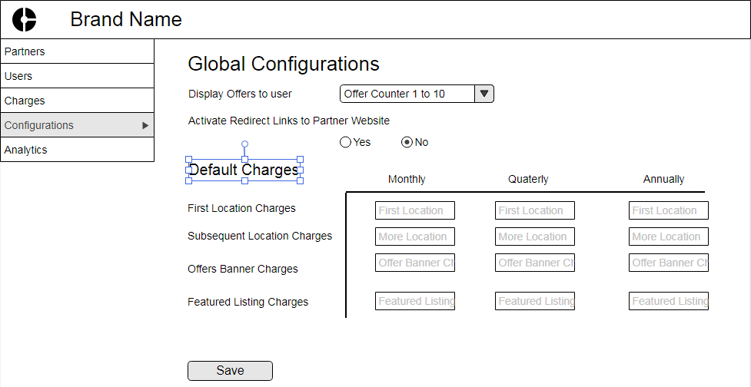

## Partner Settings

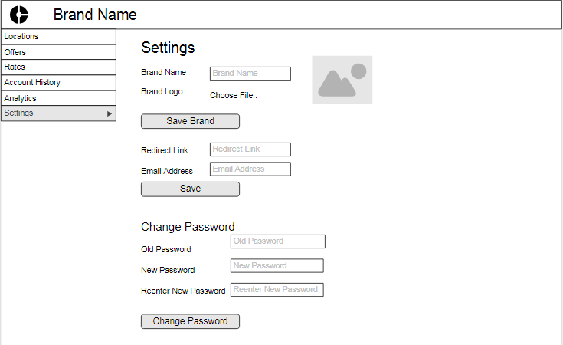

## Partner Rates

